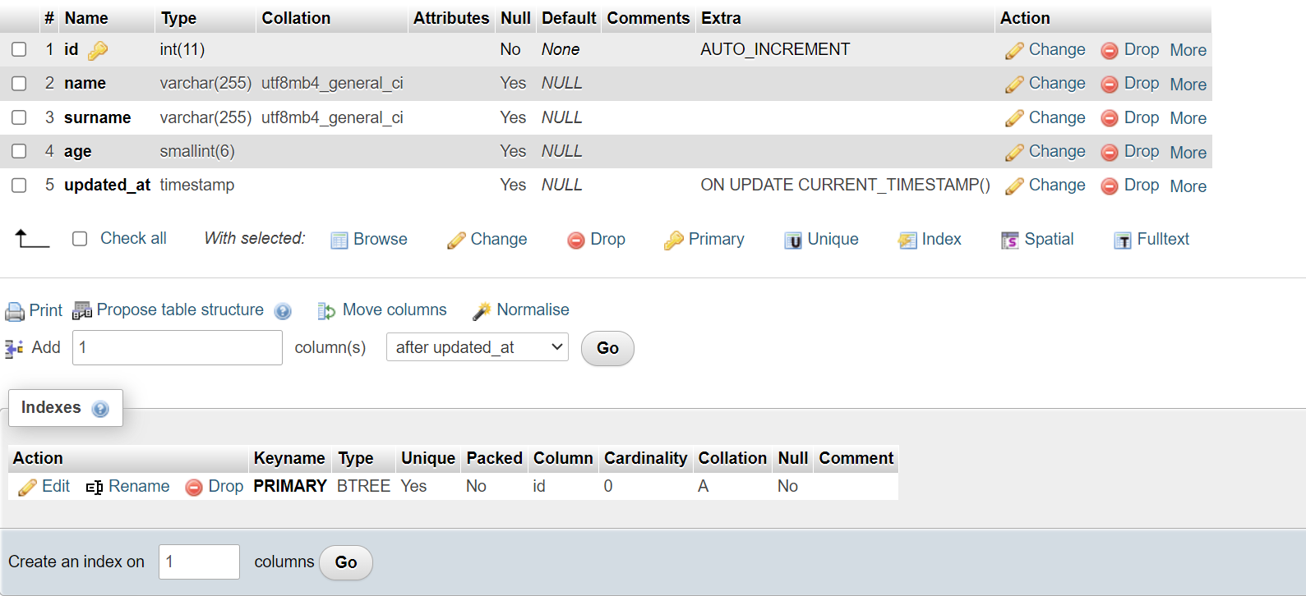
DROP DATABASE IF EXISTS task;
CREATE DATABASE task;
CREATE TABLE task.student
(
id int NULL,
name text,
surname varchar(255),
age SMALLINT,
updated_at timestamp NULL ON UPDATE CURRENT_TIMESTAMP()
);

ALTER TABLE task.student
MODIFY id int NOT NULL AUTO_INCREMENT PRIMARY KEY,
MODIFY name varchar(255);

